**Product Backlog**

*Team Number: 11*

*Team Leader: Zhuo Chen*

*Team Members: Peng Liang, Wenting Shi, Yik Fei Wong, Hon Kwan Wu, Tianyi Zhang*

*Project Name: What Does the Board Say?*

1. Problem Statement:

People need a mobile application to work together remotely. We aim to provide a one-stop solution for image, text and voice transfer on mobile platform for users.

2. Background:

When people are doing remote meetings, they usually need to use several tools in order to achieve a simple goal, like teaching. For example, we may need to use Skype to have video chat and at the same time type in Google Docs. Also, people who can’t reach PCs and laptops are unable to join the meeting.

Our product will be designated to mobile platform (Android, iOS tablets) for Education institutions (Remote Education), Business companies (Business conferences/meetings, Brainstorming), Friends (Vacation planning, etc.), Artists (Cooperating creation) and so

on.

There are some applications similar to our planned work: Skype, Google Doc, SyncPad. The limitations of them are listed below:

(1) None of them supports both the video chat, whiteboard/text functions, which causes inconveniences for group works remotely.

(2) They cannot be used simultaneously on mobile platforms due to the limitations of multitasking applications.

3. Diagram

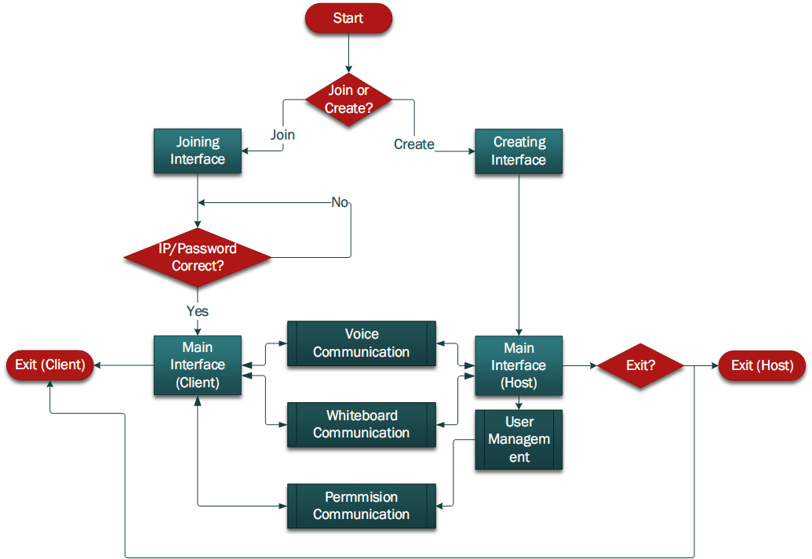

b. Description of the interactions:

* Start-up page: The app starts with an interface asking users to select “Create a whiteboard” or “Join a whiteboard”.
* Create page: The app will first prompt the IP address of the host device. Then, the host can invite others via email or other way.
* Join page: The app will display two text fields. Each User can join the whiteboard interface by entering host IP and password.
* Client: The client will send the changes they just made on the whiteboard and voice stream if Voice Chat is on to the host. They will receive and reflect the changes to the whiteboard as well as playing the audio if they receive voice message from the main interface (send by host).
* Host: Server of the main interface will be assigned to the host who created the page. Server is the core communication tool between clients, it will collect data send by different clients then compress and send them to main interface. When the host (server) decide to exit/terminate the main interface, every other device connect to the main interface will also be terminated.
* User manage: the host can use the User Management function to modify participants’ privileges of the usage for whiteboard or other functions and better manage the users environment.
* Main interface: The main page is the work space for all users. All changes made on the workspace will be synchronized to other users’ whiteboard. Also, the video function and several settings/preferences/modes are supported.
* Whiteboard communication: receive/send whiteboard message from/to the main interface.
* Voice communication: receive/send voice message from/to the main interface.
* End_host: Exit function will have different implementation between host and client. An exit function execute on host will cause termination on all other client.
* End_client: Exit function will have different implementation between host and client.

An exit function on client will cause termination on only the client who decide to

terminate.

4. Requirements:

Section 1: Must be done

* Functional requirements

(1) Invite function for host

As a host user, I would like to create a whiteboard.

|  |  |
| --- | --- |
| User action | System Response |
| 1. Click host button  3. Confirm to create a whiteboard | 2. Show host interface with IP address  4. Establish server and show the whiteboard |

As a host user, I would like to invite others while creating the whiteboard.

|  |  |
| --- | --- |
| User action | System Response |
| 2. Click on “+” button | 1. Show “+” button  3. Ask user to input invitee’s email or choose recent invitee |

As a host user, I would like to invite others while creating the whiteboard.

|  |  |
| --- | --- |
| User action | System Response |
| 1. User clicks on invitation link | 2. Try to connect host immediately  3. a) Establish connection to the server and show the whiteboard if password is right  b) Tell the user to retry if password is wrong |

(2) Join function for participant:

As a client user, I would like to join the whiteboard.

|  |  |
| --- | --- |
| User action | System Response |
| 1. Click join button  3. Confirm to join a whiteboard | 2. Ask user to input host IP and password  4. a) Establish connection to the server and show the whiteboard if password is right  b) Tell the user to retry if password is wrong |

(3) Basic whiteboard functions (draw, erase, clear, undo, redo):

As a user, I would like to modify my drawing anytime I want.

|  |  |
| --- | --- |
| User action | System Response |
| 1. Click the function button  3. User do action on the board | 2. Change the touch screen response according to the function  4. The changes are reflected on the whiteboard. |

(4) Synchronized whiteboard communications:

As a user, I would like the changes I made being synchronized to other users’ whiteboard.

|  |  |
| --- | --- |
| User action | System Response |
| 1. Changes are made by users on the whiteboard | 2. All the changes are sent to others’ whiteboard through the server.  3. Changes are reflected on the board. |

(5) Pencil/Eraser second toolbar with color and size setting functions:

As a user, I would like to modify with different colors, pen size or eraser size.

|  |  |
| --- | --- |
| User action | System Response |
| 1. Double-Click the pen/eraser button  3. User change size/color in the menu | 2. Size/color menu pops up  4. The option is recorded and reflect on the icon of the button |

(6) Text edits function:

As a user, I would like to add text on the board.

|  |  |
| --- | --- |
| User action | System Response |
| 1. Click the Text button  4. Drag the box with dotted line  6. Type with the keyboard  7. Confirm the text | 2. A box with dotted line shows up.  3. Keyboard shows up.  5. Text box moves with the thumb  8. Text finalized |

(7) Voice chat function:

As a user, I would like the voice chat with the others.

|  |  |
| --- | --- |
| User action | System Response |
| 1. User hold the voice chat button and speak  5. User listens to others’ voice | 2. System start recording users voice  3. User’s voice is being compressed  4. User’s voice is being sent to other users through the server. |

(8) Exit function:

As a user, I would like to know who leave the whiteboard.

|  |  |
| --- | --- |
| User action | System Response |
| 1. Someone leaves the whiteboard | 2. Server realizes that since no data is transferred from that client  3. Reflect on everyone’s user list |

As a host, I would like to terminate the whiteboard when I leave.

|  |  |
| --- | --- |
| User action | System Response |
| 1. Choose to exit the whiteboard | 2. Send termination signal to every client  3. Terminate the whiteboard  4. Clients terminate the whiteboard when receive the termination signal |

* Non-functional requirements

(1) Smooth of processing whiteboard:

As a user, I would like to communicate with others in the whiteboard smoothly.

(2) Optimize delay time:

As a user, I would like to get shorter delay of others’ updates.

(3) Application stability for multi-users:

As a user, I would like the application being stable for multiple users.

Section 2: Will be done if time allows

* Functional requirements

(1) User Management:

As a host user, I would like to manage the privileges of other participants.

|  |  |
| --- | --- |
| User action | System Response |
| 1. Host changes the privileges of each user | 2. System changes the specific user’s privileges of voice/whiteboard |

(2) Settings:

As a host user, I would like to set language or preference on my own device.

|  |  |
| --- | --- |
| User action | System Response |
| 1. Host uses “Settings” to manage the “Language” or “Preference” | 2. “Language” or “Preference” can be changed and applied on the current user’s whiteboard. |

As a host user, I would like to log out the current account.

|  |  |
| --- | --- |
| User action | System Response |
| 1. Host uses “Settings” to choose “Logout”. | 2. System log current account out. Then shows the initial interface, which is “Create a Whiteboard or Join a Whiteboard”. |

(3) Graphic Import:

As a host user, I would like to import a graphic.

|  |  |
| --- | --- |
| User action | System Response |
| 1. Host chooses “Import Graphic”. | 2. System allows users to choose a picture from device and insert that picture to appear onto whiteboard. |

(4) Save & Load:

As a host user, I would like to save the work on my current whiteboard interface.

|  |  |
| --- | --- |
| User action | System Response |
| 1. Host chooses “Save”. | 2. System saves the current whiteboard in an editable format to the default folder. |

As a host user, I would like to load my previously unfinished work on my current whiteboard interface.

|  |  |
| --- | --- |
| User action | System Response |
| 1. Host chooses “Load”. | 2. System allows users to choose a saved work from device and allow user to resume it on whiteboard. |

(5) Voice chat lock function:

As a user, I would like to switch to and remain in a chatting room mode.

|  |  |
| --- | --- |
| User action | System Response |
| 1. Switch chatting button from left to the right  3. Click the button once  5. Click the button one more time | 2. System changes to a chatting room mode  4. System remains in a chatting room mode  6. System back to a hold-and-speak mode |

(6) Mute function:

As a user, I would like to mute all other participants.

|  |  |
| --- | --- |
| User action | System Response |
| 1. Click mute button  3. Click mute button one more time | 2. The user temporarily blocks from the group chat  4. The user back to the group chat again |

(7) Mode: Notebook, Doc:

As a user, I would like to select from a notebook or a document mode.

|  |  |
| --- | --- |
| User action | System Response |
| 1. Click “mode” button  3. Select “Notebook”  5. Select “Doc” | 2. A drop-down menu shows up  4. The edit board will show like a notebook  5. The edit board will show like a document |

(8) Password Setting:

As a host user, I would like set password for the whiteboard I created.

|  |  |
| --- | --- |
| User action | System Response |
| 1. Host fills the password text field in the create page  3. Other participants go to the join page and enter the password  5. The participant will join the whiteboard or retry the password | 2. System stores the password set  4. System check whether the password is correct or not |

(9) Historical list:

As a user, I would like to create a historical list for keeping my recent contacts.

|  |  |
| --- | --- |
| User action | System Response |
| 1. Users join in a whiteboard  3. The host can add contacts from historical list in the create page | 2. System stores every user’s information into its local databases  4. System accesses the local databases and fill the information automatically |

(10) Participants status:

As a user, I would like to see others status.

|  |  |
| --- | --- |
| User action | System Response |
| 1. Users join in a whiteboard  3. Users can change preferences of the status bar in settings | 2. System shows each user’s status in the right upper corner of the main interface |

* Non-functional requirements

(1) Good design of User Interfaces:

As a user, I would like the interfaces being more friendly.

(2) Icon designs:

As a user, I would like the designs of icons more impressive.

(3) Supporting iOS tablet:

As a user, I would like the application supporting iPad as well.